Power Fang Enterprise Company Ltd
Professional fluid control field
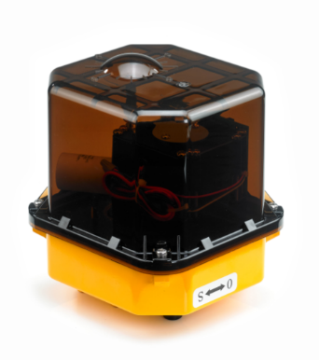
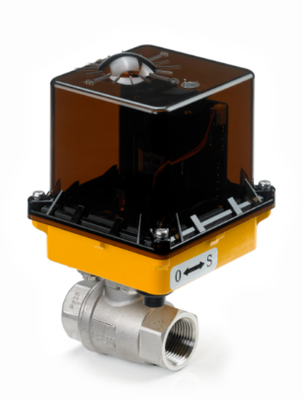
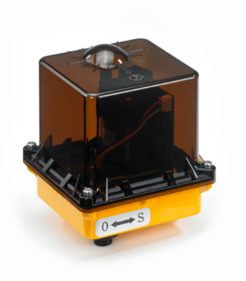

JS-03
JS-01
JS-02
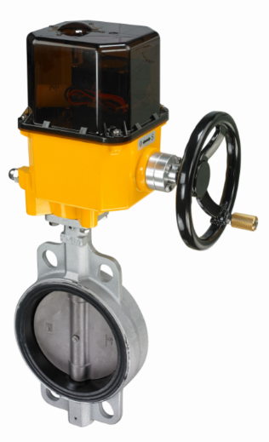
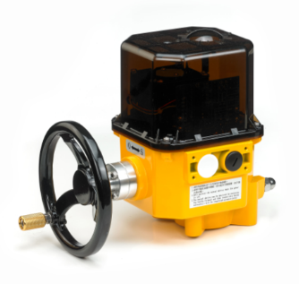

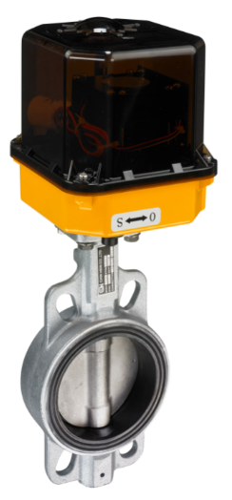

JS-04H with butterly valve
JS-02 (2)
JS-02 (3)
JS-01 with ball valve
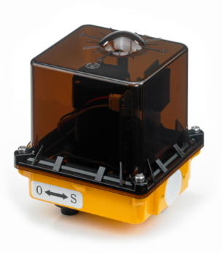
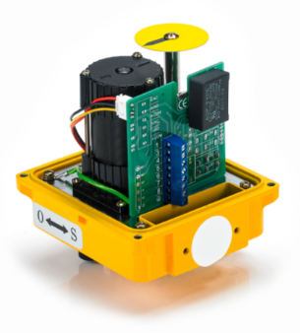
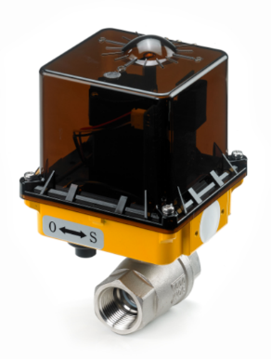
JS-06H
JS-05H
JS-04
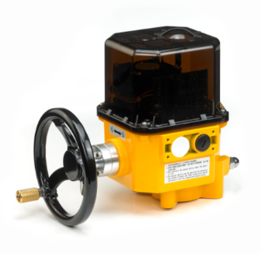
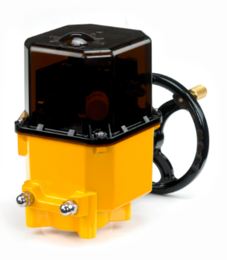
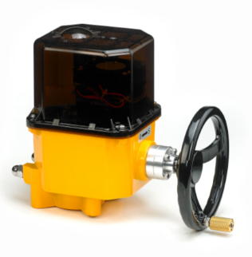
JS-03H
JS-03
Power Fang Enterprise Company Ltd
The information of the specifications & the features
Operation Voltage of  Various Types | Standard  ON/OFF Type | “Low Energy”  ON/OFF Type | “Fast Acting”  ON/OFF Type
Operation Voltage of  Various Types | 12 V_{DC}  24 V_{DC}  24 V_{AC/DC}  110/220 V_{AC} (1-Phase)  220/380/440/460 V_{AC} (3-Phase) | 110/220 V_{AC} (1-Phase) | 12 VDC  24 VDC  24 VAC/DC  110/220 VAC (1-Phase)
Operation Voltage of  Various Types | Modulation Type | “Battery Backup Fail-safe”  ON/OFF Type
Operation Voltage of  Various Types | 24/110/220 V_{AC} (1-Phase) | 12 V_{DC}  24 V_{AC/DC}  110/220 V_{AC} (1-Phase)
Protection Class | IP 67 according to STD. IEC 60529
Working Condition | Ambient Temperature: -10 to 60°C (14 to 140°F)  The humidity: 30% ~ 95%
Rotation Angle | 0~270°
Enclosure | Case Material：Aluminum alloy  Cover Material：Polycarbonate
Certiﬁcation / Test | Comply with CE directives of  - The LOW Voltage Directive, 73/23/EEC, 93/68 EEC  - The EMC Directive, 89/336/EEC
Mounting Flange | ISO 5211
Conduit Entrance | 1/2"PF
Accessory | -Cable gland(IP68) x 1 p(Cable range: Ø10~6mm)  -Protection for manual lever – rubber cover
Optional Items | -Space heater  -Additional limit switches x2 (250VAC / 0.1A)  -Built -in LED position indicator  -Modulating controller  -Potentiometer unit (5k Ohm).  -Three-positioning type for 110/220V_{AC}  (Choose three angular positions from 0°~270°.)

Model | Manual Override | Valve Mounting Flange (ISO 5211)
JS-01~02 | Lever | F03, F04, F05, F07
JS-03 | Lever | F05, F07
JS-03H~06H | Hand Wheel | F07, F10, F12
JS-06H-T08~10 | Hand Wheel | F10, F12 & F10, F14
Power Fang Enterprise Company Ltd
e-mail : pfpf01@gmail.com
What’s App : 886 955789002
Tel no.: 886 2 8283 9836
Power Fang Enterprise Company Ltd
The chart of the performance
- Standard ON/OFF Type
Standard ON/OFF Type, 12V_{DC}
Model | Torque |  | Cycle Time  (sec /90°) | Duty Cycle  * | Maximum  Operating  Current | Rated  Current | Overload  Protection  Device | Weight
Model | N·m | lbf·in |  |  |  |  |  | kg | lbs
JS-01 | 35 | 310 | 10-15 | 100% | 10A | 1.5A | F*-1.25A | 1.9 | 4.2
JS-02 | 50 | 443 | 10-16 |  |  |  |  | 1.9 | 4.2

Standard ON/OFF Type, 24V_{DC}
Model | Torque |  | Cycle Time  (sec /90°) | Duty Cycle  * | Maximum  Operating  Current | Rated  Current | Overload  Protection  Device | Weight
Model | N·m | lbf·in |  |  |  |  |  | kg | lbs
JS-01 | 35 | 310 | 11-16 | 100% | 2.8A | 0.9A | F*-1.0A | 1.9 | 4.2
JS-02 | 50 | 443 | 12-18 | 100% | 3.2A | 0.8A | F*-1.0A | 1.9 | 4.2
JS-03 | 140 | 1238 | 7-13 | 100% | 5.4A | 2.6A | F*-3.0A | 3.9 | 8.6
JS-03H* | 160 | 1416 | 10-15 |  |  |  |  | 6.9 | 15.2
JS-04H* | 275 | 2434 | 27-47 |  |  |  |  | 7.6 | 16.8
JS-06H-T08* | 800 | 7080 | 88-120 |  |  |  |  | 14 | 30.8

Standard ON/OFF Type, 24V_{AC/DC}
Model | Torque |  | Cycle Time  (sec /90°) | Duty Cycle  * | Maximum  Operating  Current | Rated  Current | Overload  Protection  Device | Weight
Model | N·m | lbf·in |  |  |  |  |  | kg | lbs
JS-01 | 35 | 310 | 11-16 | 100% | 2.8A | 0.9A | F*-0.8A | 1.9 | 4.2
JS-02 | 50 | 443 | 12-18 | 100% | 3.2A | 0.8A | F*-0.8A | 1.9 | 4.2
JS-03 | 140 | 1238 | 7-13 | 100% | 3.2A | 2.6A | F*-3.0A | 3.9 | 8.6
JS-03H* | 160 | 1416 | 10-15 |  |  |  |  | 6.9 | 15.2
JS-04H* | 275 | 2434 | 27-47 |  |  |  |  | 7.6 | 16.8
JS-06H-T08* | 800 | 7080 | 88-120 |  |  |  |  | 14 | 30.8

Note *
(1) Duty Cycle：The definition of Duty Cycle is in accordance with IEC60034-S4 duty type.
(2) H：In the part number indicates hand-wheel manual override.
(3) F：Fast acting fuse.
Power Fang Enterprise Company Ltd
e-mail : pfpf01@gmail.com
What’s App : 886 955789002
Tel no.: 886 2 8283 9836
Power Fang Enterprise Company Ltd
Standard ON/OFF Type, 110V_{AC} (1-Phase)
Model | Torque |  | Cycle Time  ( sec /90°) |  | Duty Cycle* | Rated  Current | Overload  Protection  Device | Weight
Model | N·m | lbf·in | 50Hz | 60Hz | Duty Cycle* | 50/60Hz | Overload  Protection  Device | kg | lbs
JS-01 | 35 | 310 | 12 | 10 | 20% 15min | 0.7A | TP* | 1.7 | 3.7
JS-02 | 50 | 443 | 12 | 10 | 20% 15min | 0.9A | TP* | 1.8 | 3.9
JS-03 | 170 | 1505 | 10 | 8 | 50% 60min | 1.2A | TP* | 4.4 | 9.7
JS-03H* | 200 | 1770 | 12 | 10 | 50% 60min | 1.2A | TP* | 7.9 | 17.4
JS-04H* | 380 | 3363 | 36 | 30 | 50% 60min | 1.2A | TP* | 8.6 | 19.0
JS-05H* | 500 | 4425 | 36 | 30 | 50% 60min | 2.0A | TP* | 8.8 | 19.4
JS-06H* | 600 | 5310 | 36 | 30 | 50% 60min | 2.4A | TP* | 9.1 | 20.1
JS-06H*-T08 | 1100 | 9735 | 106 | 88 | 50% 60min | 2.0A | TP* | 14.5 | 31.9
JS-06H*-T09 | 1500 | 13275 | 106 | 88 | 50% 60min | 2.0A | TP* | 14.8 | 32.6
JS-06H*-T10 | 1800 | 15930 | 106 | 88 | 50% 60min | 2.8A | TP* | 15.2 | 33.5

Standard ON/OFF Type, 220V_{AC} (1-Phase)
Model | Torque |  | Cycle Time  ( sec /90°) |  | Duty Cycle* | Rated  Current | Overload  Protection  Device | Weight
Model | N·m | lbf·in | 50Hz | 60Hz | Duty Cycle* | 50/60Hz | Overload  Protection  Device | kg | lbs
JS-01 | 35 | 310 | 12 | 10 | 20% 15min | 0.4A | TP* | 1.7 | 3.7
JS-02 | 50 | 443 | 12 | 10 | 20% 15min | 0.50A | TP* | 1.8 | 3.9
JS-03 | 170 | 1505 | 10 | 8 | 50% 60min | 0.8A | TP* | 4.4 | 9.7
JS-03H* | 200 | 1770 | 12 | 10 | 50% 60min | 0.8A | TP* | 7.9 | 17.4
JS-04H* | 380 | 3363 | 36 | 30 | 50% 60min | 0.8A | TP* | 8.6 | 19.0
JS-05H* | 500 | 4425 |  |  |  |  |  | 8.8 | 19.4
JS-06H* | 600 | 5310 |  |  |  |  |  | 9.1 | 20.1
JS-06H*-T08 | 1100 | 9735 | 106 | 88 | 50% 60min | 1.0A | TP* | 14.5 | 31.9
JS-06H*-T09 | 1500 | 13275 | 106 | 88 | 50% 60min | 1.0A | TP* | 14.8 | 32.6
JS-06H*-T10 | 1800 | 15930 | 106 | 88 | 50% 60min | 1.1A | TP* | 15.2 | 33.5

Note *
(1) Duty Cycle：The definition of Duty Cycle is in accordance with IEC60034-S4 duty type.
(2) H：In the part number indicates hand-wheel manual override.
(3) TP：Indicates motor thermal overload protector.

Power Fang Enterprise Company Ltd
e-mail : pfpf01@gmail.com
What’s App : 886 955789002
Tel no.: 886 2 8283 9836
Power Fang Enterprise Company Ltd

Standard ON/OFF Type, 220V_{AC} (3-Phase)
Model | Torque |  | Cycle Time  (sec /90°) |  | Duty Cycle* | Rated  Current | Overload  Protection  Device | Weight
Model | N·m | lbf·in | 50Hz | 60Hz | Duty Cycle* | 50/60Hz | Overload  Protection  Device | kg | lbs
JS-03 | 170 | 1505 | 10 | 8 | 50% 60min | 0.7A | TP* | 4.4 | 9.7
JS-03H* | 200 | 1770 | 12 | 10 | 50% 60min | 0.7A | TP* | 7.9 | 17.4
JS-04H* | 380 | 3363 | 36 | 30 | 50% 60min | 0.7A | TP* | 8.6 | 19.0
JS-05H* | 500 | 4425 | 36 | 30 | 50% 60min | 0.9A | TP* | 8.8 | 19.4
JS-06H* | 600 | 5310 | 36 | 30 | 50% 60min | 0.9A | TP* | 9.1 | 20.1
JS-06H*-T08 | 1100 | 9735 | 106 | 88 | 50% 60min | 0.9A | TP* | 14.5 | 31.9
JS-06H*-T10 | 1800 | 15930 | 106 | 88 | 50% 60min | 0.9A | TP* | 15.2 | 33.5

Standard ON/OFF Type, 380/440/460V_{AC} (3-Phase)
Model | Torque |  | Cycle Time  (sec /90°) |  | Duty Cycle* | Rated  Current | Overload  Protection  Device | Weight
Model | N·m | lbf·in | 50Hz | 60Hz | Duty Cycle* | 50/60Hz | Overload  Protection  Device | kg | lbs
JS-03 | 170 | 1505 | 10 | 8 | 50%  60min | 0.5A | TP* | 4.4 | 9.7
JS-03H* | 200 | 1770 | 12 | 10 | 50%  60min | 0.5A | TP* | 7.9 | 17.4
JS-04H* | 380 | 3363 | 36 | 30 | 50%  60min | 0.5A | TP* | 8.6 | 19.0
JS-05H* | 500 | 4425 | 36 | 30 | 50%  60min | 0.5A | TP* | 8.8 | 19.4
JS-06H* | 600 | 5310 | 36 | 30 | 50%  60min | 0.5A | TP* | 9.1 | 20.1
JS-06H*-T08 | 1100 | 9735 | 106 | 88 | 50%  60min | 0.5A | TP* | 14.5 | 31.9
JS-06H*-T10 | 1800 | 15930 | 106 | 88 | 50%  60min | 0.5A | TP* | 15.2 | 33.5

Note *
(1) Duty Cycle：The definition of Duty Cycle is in accordance with IEC60034-S4 duty type.
(2) H：In the part number indicates hand-wheel manual override.
(3) TP：Indicates motor thermal overload protector.

Power Fang Enterprise Company Ltd
e-mail : pfpf01@gmail.com
What’s App : 886 955789002
Tel no.: 886 2 8283 9836

Power Fang Enterprise Company Ltd
- “Low Energy” ON/OFF Type
“Low Energy” ON/OFF Type, 110V_{AC} (1-Phase)
Model | Torque |  | Cycle Time  (sec /90°) |  | Duty Cycle* | Rated  Current | Overload  Protection  Device | Weight
Model | N·m | lbf·in | 50Hz | 60Hz | Duty Cycle* | 50/60Hz | Overload  Protection  Device | kg | lbs
JS-01A | 32 | 283 | 19 | 16 | 100% | 0.2A | N/A | 1.7 | 3.7
JS-02A | 36 | 319 | 20 | 17 | 40% 60min | 0.3A | TP* | 1.75 | 3.9
JS-02A | 50 | 443 | 43 | 36 | 100% | 0.2A | N/A | 1.8 | 4.0
JS-03A | 90 | 797 | 42 | 35 | 40% 60min | 0.3A | N/A | 3.5 | 7.7
JS-03A | 120 | 1062 | 65 | 54 | 40% 60min | 0.3A | N/A | 3.5 | 7.7
JS-03A | 100 | 885 | 65 | 54 | 100% | 0.2A | N/A | 3.5 | 7.7

“Low Energy” ON/OFF Type, 220V_{AC} (1-Phase)
Model | Torque |  | Cycle Time  (sec /90°) |  | Duty Cycle* | Rated  Current | Overload  Protection  Device | Weight
Model | N·m | lbf·in | 50Hz | 60Hz | Duty Cycle* | 50/60Hz | Overload  Protection  Device | kg | lbs
JS-01A | 32 | 283 | 19 | 16 | 100% | 0.10A | N/A | 1.7 | 3.7
JS-02A | 36 | 319 | 20 | 17 | 40% 60min | 0.15A | TP* | 1.75 | 3.9
JS-02A | 50 | 443 | 43 | 36 | 100% | 0.10A | N/A | 1.8 | 4.0
JS-03A | 90 | 797 | 42 | 35 | 40% 60min | 0.15A | N/A | 3.5 | 7.7
JS-03A | 120 | 1062 | 65 | 54 | 40% 60min | 0.15A | N/A | 3.5 | 7.7
JS-03A | 100 | 885 | 65 | 54 | 100% | 0.10A | N/A | 3.5 | 7.7

Note *
(1) Duty Cycle：The definition of Duty Cycle is in accordance with IEC60034-S4 duty type.
(2) TP：Indicates motor thermal overload protector.

Power Fang Enterprise Company Ltd
e-mail : pfpf01@gmail.com
What’s App : 886 955789002
Tel no.: 886 2 8283 9836
Power Fang Enterprise Company Ltd
- “Fast Acting” ON/OFF Type
“Fast Acting” ON/OFF Type, 12V_{DC}
Model | Torque |  | Cycle Time  (sec /90°) | Duty Cycle* | Maximum  Operating  Current | Rated  Current | Overload  Protection  Device | Weight
Model | N·m | lbf·in |  |  |  |  |  | kg | lbs
JS-01 | 10 | 89 | 1-2 | 100% | 10A | 3.3A | F*-3.0A | 1.9 | 4.2
JS-01 | 25 | 221 | 3-6 | 100% | 10A | 2.5A | F*-2.0A | 1.9 | 4.2

“Fast Acting” ON/OFF Type, 24V_{DC}
Model | Torque |  | Cycle Time  (sec /90°) | Duty Cycle* | Maximum  Operating  Current | Rated  Current | Overload  protection  device | Weight
Model | N·m | lbf·in |  |  |  |  |  | kg | lbs
JS-01 | 10 | 89 | 1-2 | 100% | 3.2A | 1.9A | F*-1.5A | 1.9 | 4.2
JS-01 | 25 | 221 | 3-8 | 100% | 3.2A | 1.3A | F*-1.5A | 1.9 | 4.2
JS-03 | 30 | 226 | 1-3 | 100% | 5.4A | 4A | F*-3.0A | 3.9 | 8.6
JS-03 | 60 | 531 | 4-7 | 100% | 5.4A | 1.9A | F*-3.0A | 3.9 | 8.6

“Fast Acting” ON/OFF Type, 24V_{AC/DC}
Model | Torque |  | Cycle Time  (sec /90°) | Duty Cycle* | Maximum  Operating  Current | Rated  Current | Overload  Protection  Device | Weight
Model | N·m | lbf·in |  |  |  |  |  | kg | lbs
JS-01 | 10 | 89 | 1-2 | 100% | 3.2A | 1.9A | F*-1.5A | 1.9 | 4.2
JS-01 | 25 | 221 | 3-8 | 100% | 3.2A | 1.3A | F*-1.5A | 1.9 | 4.2
JS-03 | 30 | 226 | 1-3 | 100% | 5.4A | 4A | F*-3.0A | 3.9 | 8.6
JS-03 | 60 | 531 | 4-7 | 100% | 5.4A | 1.9A | F*-3.0A | 3.9 | 8.6

Note *
(1) Duty Cycle：The definition of Duty Cycle is in accordance with IEC60034-S4 duty type.
(2) F：Fast acting fuse.
Power Fang Enterprise Company Ltd
e-mail : pfpf01@gmail.com
What’s App : 886 955789002
Tel no.: 886 2 8283 9836
Power Fang Enterprise Company Ltd
“Fast Acting” ON/OFF Type, 110V_{AC} (1-Phase)
Model | Torque |  | Cycle Time  (sec /90°) |  | Duty Cycle* | Rated  Current | Overload  Protection  Device | Weight
Model | N·m | lbf·in | 50Hz | 60Hz | Duty Cycle* | 50/60Hz | Overload  Protection  Device | kg | lbs
JS-01 | 9 | 80 | 1.2 | 1 | 50% 60min | 1.2A | TP* | 1.9 | 4.2
JS-01 | 25 | 221 | 4 | 3 | 50% 60min | 1.2A | TP* | 1.9 | 4.2
JS-03 | 35 | 310 | 1.2 | 1 | 50% 60min | 1.2A | TP* | 3.9 | 8.6
JS-03 | 100 | 885 | 6 | 5 | 50% 60min | 1.2A | TP* | 3.9 | 8.6

“Fast Acting” ON/OFF Type, 220V_{AC} (1-Phase)
Model | Torque |  | Cycle time  (sec /90°) |  | Duty Cycle* | Rated  Current | Overload  protection  device | Weight
Model | N·m | lbf·in | 50Hz | 60Hz | Duty Cycle* | 50/60Hz | Overload  protection  device | kg | lbs
JS-01 | 9 | 80 | 1.2 | 1 | 50% 60min | 0.38A | TP* | 1.9 | 4.2
JS-01 | 25 | 221 | 4 | 3 | 50% 60min | 0.60A | TP* | 1.9 | 4.2
JS-03 | 35 | 310 | 1.2 | 1 | 50% 60min | 0.72A | TP* | 3.9 | 8.6
JS-03 | 100 | 885 | 6 | 5 | 50% 60min | 0.72A | TP* | 3.9 | 8.6

Note *
(1) Duty Cycle：The definition of Duty Cycle is in accordance with IEC60034-S4 duty type.
(2) TP：Indicates motor thermal overload protector.

Power Fang Enterprise Company Ltd
e-mail : pfpf01@gmail.com
What’s App : 886 955789002
Tel no.: 886 2 8283 9836
Power Fang Enterprise Company
- Modulation Type
The differences between AMD and BMD:
There are two differences of using of the motors between AMD and BMD. One AMD model runs with synchronous motors, the other BMD model runs with inductive motors.
There are two Comparison of AMD and BMD : AMD has lower power consumption which saves electricity. BMD has more powerful torque value and much faster.

Modulation Type, 24V_{AC} (1-Phase)
Model | Torque |  | Cycle Time  (sec /90°) |  | Duty  Cycle  * | Rated  Current | Overload Protection Device |  | Weight
Model | N·m | lbf·in | 50Hz | 60Hz | Duty  Cycle  * | 50/60Hz | MOTOR | PCB | kg | lbs
JS-01-AMD | 20 | 177 | 19 | 16 | 100% | 0.8A | F*-1.0A  TP* | F*-0.5A | 2.1 | 4.6
JS-02-AMD | 45 | 398 | 43 | 36 |  |  |  |  | 2.1 | 4.6
JS-03-AMD | 75 | 664 | 42 | 35 |  |  |  |  | 3.7 | 8.2
JS-03-AMD | 110 | 974 | 65 | 54 |  |  |  |  | 3.7 | 8.2

Note *
(1) Duty Cycle：The definition of Duty Cycle is in accordance with IEC60034-S4 duty type.
(2) F：Fast acting fuse.
(3) TP：Indicates motor thermal overload protector.

Power Fang Enterprise Company Ltd
e-mail : pfpf01@gmail.com
What’s App : 886 955789002
Tel no.: 886 2 8283 9836

Power Fang Enterprise Company Ltd

Modulation Type, 110V_{AC} (1-Phase)
Model | Torque |  | Cycle Time  (sec /90°) |  | Duty  Cycle  * | Rated  Current | Overload Protection device |  |  | Weight
Model | N·m | lbf·in | 50Hz | 60Hz | Duty  Cycle  * | 50/60Hz | MOTOR | PCB |  | kg | lbs
JS-01-AMD | 25 | 221 | 19 | 16 | 100% | 0.2A | F*-0.5A  TP* |  | F*-0.15A | 2.1 | 4.6
JS-02-AMD | 36 | 319 | 19 | 16 | 50% 60min | 0.3A |  |  | F*-0.15A | 2.1 | 4.6
JS-02-AMD | 50 | 443 | 43 | 36 | 100% | 0.2A |  |  | F*-0.15A | 2.1 | 4.6
JS-03-AMD | 100 | 885 | 42 | 35 | 50% 60min | 0.3A |  |  | F*-0.15A | 3.7 | 8.2
JS-03-AMD | 120 | 1062 | 65 | 54 | 50% 60min | 0.3A |  |  | F*-0.15A | 3.7 | 8.2
JS-03-BMD | 170 | 1505 | 10 | 8 | 50% 60min | 1.2A | F*-1.5A  TP* |  | F*-0.15A | 4.8 | 10.6
JS-03H*  -BMD | 200 | 1770 | 12 | 10 | 50% 60min | 1.2A |  |  | F*-0.15A | 8.3 | 18.3
JS-04H*  -BMD | 300 | 2655 | 36 | 30 | 50% 60min | 1.2A |  |  | F*-0.15A | 9.0 | 19.8
JS-05H*  -BMD | 500 | 4425 | 36 | 30 | 50% 60min | 2.0A | F*-3.0A  TP* |  | F*-0.15A | 9.2 | 20.3
JS-06H*  -BMD | 600 | 5310 | 36 | 30 | 50% 60min | 2.4A |  |  | F*-0.15A | 9.5 | 20.9
JS-06H*  -BMD-T08 | 1100 | 9735 | 106 | 88 | 50% 60min | 1.2A | F*-1.5A  TP* |  | F*-0.15A | 14.5 | 31.9
JS-06H*  -BMD-T09 | 1500 | 13275 | 106 | 88 | 50% 60min | 2.0A | F*-3.0A  TP* |  | F*-0.15A | 14.8 | 32.6
JS-06H*  -BMD-T10 | 1800 | 15930 | 106 | 88 | 50% 60min | 2.4A |  |  | F*-0.15A | 15.2 | 33.5

Power Fang Enterprise Company Ltd
e-mail : pfpf01@gmail.com
What’s App : 886 955789002
] Tel no.: 886 2 8283 9836

Power Fang Enterprise Company
Note *
(1) Duty Cycle：The definition of Duty Cycle is in accordance with IEC60034-S4 duty type.
(2) H：In the part number indicates hand-wheel manual override
(3) F：Fast acting fuse.
(4) TP：Indicates motor thermal overload protector.
Modulation Type, 220V_{AC} (1-Phase)
Model | Torque |  | Cycle Time  (sec /90°) |  | Duty  Cycle* | Rated  Current | Overload Protection Device |  | Weight
Model | N·m | lbf·in | 50Hz | 60Hz | Duty  Cycle* | 50/60Hz | MOTOR | PCB | kg | lbs
JS-01-AMD | 25 | 221 | 19 | 16 | 100% | 0.10A | F*-0.25A  TP* | F*-0.15A | 2.1 | 4.6
JS-02-AMD | 36 | 319 | 19 | 16 | 50% 60min | 0.15A | F*-0.25A  TP* | F*-0.15A | 2.1 | 4.6
JS-02-AMD | 50 | 443 | 43 | 36 | 100% | 0.10A | F*-0.25A  TP* | F*-0.15A | 2.1 | 4.6
JS-03-AMD | 100 | 885 | 42 | 35 | 50% 60min | 0.15A | F*-0.25A  TP* | F*-0.15A | 3.7 | 8.2
JS-03-AMD | 120 | 1062 | 65 | 54 | 50% 60min | 0.15A | F*-0.25A  TP* | F*-0.15A | 3.7 | 8.2
JS-03-BMD | 170 | 1505 | 10 | 8 | 50% 60min | 0.72A | F*-1.0A  TP* | F*-0.15A | 4.8 | 10.6
JS-03H*  -BMD | 200 | 1770 | 12 | 10 | 50% 60min | 0.72A | F*-1.0A  TP* | F*-0.15A | 8.3 | 18.3
JS-04H*  -BMD | 300 | 2655 | 36 | 30 | 50% 60min | 0.72A | F*-1.0A  TP* | F*-0.15A | 9.0 | 19.8
JS-05H*  -BMD | 500 | 4425 | 36 | 30 | 50% 60min | 0.75A | F*-1.5A  TP* | F*-0.15A | 9.2 | 20.3
JS-06H*  -BMD | 600 | 5310 | 36 | 30 | 50% 60min | 0.80A | F*-1.5A  TP* | F*-0.15A | 9.5 | 20.9
JS-06H*  -BMD-T08 | 1100 | 9735 | 106 | 88 | 50% 60min | 0.72A | F*-1.0A  TP* | F*-0.15A | 14.5 | 31.9
JS-06H*  -BMD-T09 | 1500 | 13275 | 106 | 88 | 50% 60min | 0.75A | F*-1.5A  TP* | F*-0.15A | 14.8 | 32.6
JS-06H*  -BMD-T10 | 1800 | 15930 | 106 | 88 | 50% 60min | 0.80A | F*-1.5A  TP* | F*-0.15A | 15.2 | 33.5

Note *
(1) Duty Cycle：The definition of Duty Cycle is in accordance with IEC60034-S4 duty type.
(2) H：In the part number indicates hand-wheel manual override
(3) F：Fast acting fuse.
(4) TP：Indicates motor thermal overload protector.

Power Fang Enterprise Company Ltd
e-mail : pfpf01@gmail.com
What’s App : 886 955789002
Tel no.: 886 2 8283 9836
“Battery Backup Fail-safe” ON/OFF Type
“Battery Backup Fail-safe” ON/OFF Type, 12V_{DC}
Model | Torque |  | Cycle Time  (sec /90°) |  | Duty Cycle* |  | Rated Current  (max) | Weight
JS-02-ECR | N·m | lbf·in | Normal | Power-  off line | Normal | Power-  off line | 0.8A  (1.3A) | kg | lbs
JS-02-ECR | 12 | 106 | 13-15 | 13-21 | 33%  1min | 8%  6min | 0.8A  (1.3A) | 1.6 | 3.5

“Battery Backup Fail-safe” ON/OFF Type, 24V_{AC/DC}
Model | Torque |  | Cycle time  (sec /90°) |  | Duty Cycle* |  | Rated Current  (max) | Weight
JS-02-ECR | N·m | lbf·in | Normal | Power-  off line | Normal | Power-  off line | 0.7A  (1.3A) | kg | lbs
JS-02-ECR | 12 | 106 | 13-15 | 13-21 | 33%  1min | 8%  6min | 0.7A  (1.3A) | 1.6 | 3.5

“Battery Backup Fail-safe” ON/OFF Type, 110V_{AC} (1-Phase)
Model | Torque |  | Cycle time  (sec /90°) |  | Duty Cycle* |  | Rated Current  50/60HZ  (max) | Weight
JS-02-ECR | N·m | lbf·in | Normal | Power-  off line | Normal | Power-  off line | 0.2A  (0.3A) | kg | lbs
JS-02-ECR | 12 | 106 | 13-15 | 13-21 | 33%  1min | 8%  6min | 0.2A  (0.3A) | 1.6 | 3.5

“Battery Backup Fail-safe” ON/OFF Type, 220V_{AC} (1-Phase)
Model | Torque |  | Cycle time  (sec /90°) |  | Duty Cycle* |  | Rated Current  50/60HZ  (max) | Weight
JS-02-ECR | N·m | lbf·in | Normal | Power-  off line | Normal | Power-  off line | 0.1A  (0.2A) | kg | lbs
JS-02-ECR | 12 | 106 | 13-15 | 13-21 | 33%  1min | 8%  6min | 0.1A  (0.2A) | 1.6 | 3.5
Note *
- Duty Cycle：The definition of Duty Cycle is in accordance with IEC60034-S4 duty type.
Power Fang Enterprise Company Ltd
e-mail : pfpf01@gmail.com
What’s App : 886 955789002
Tel no.: 886 2 8283 9836
- Wiring Diagram
110/220V_{AC} (1-Phase)
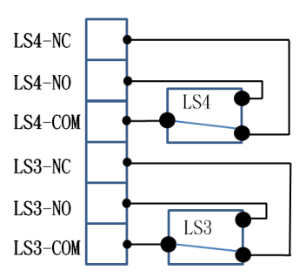
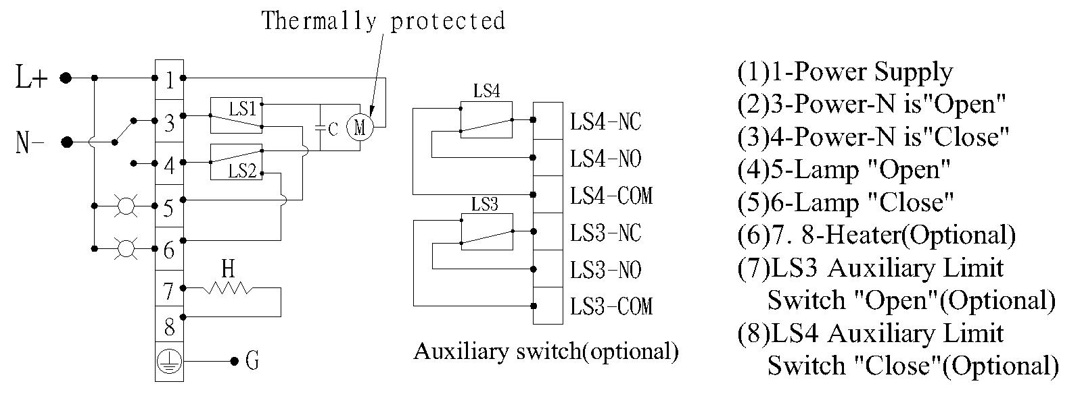
N
L

12V_{DC}, 24V_{DC}
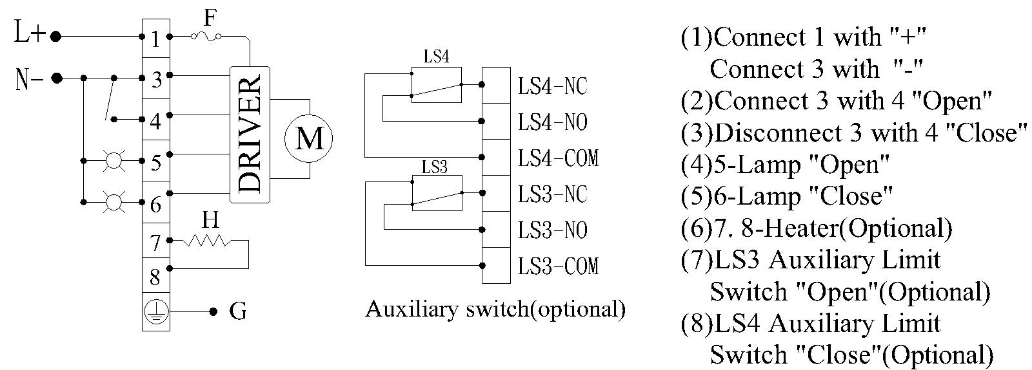

24V_{AC/DC}
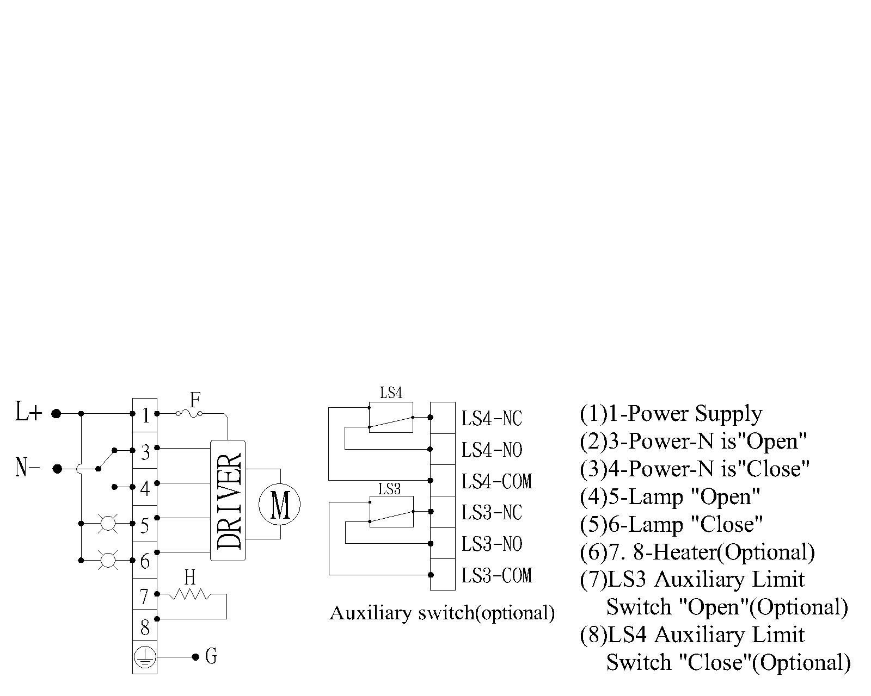
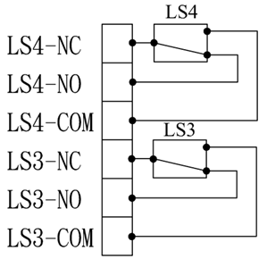
Auxiliary switch (optional)

220/380/440/460V_{AC} (3-Phase)
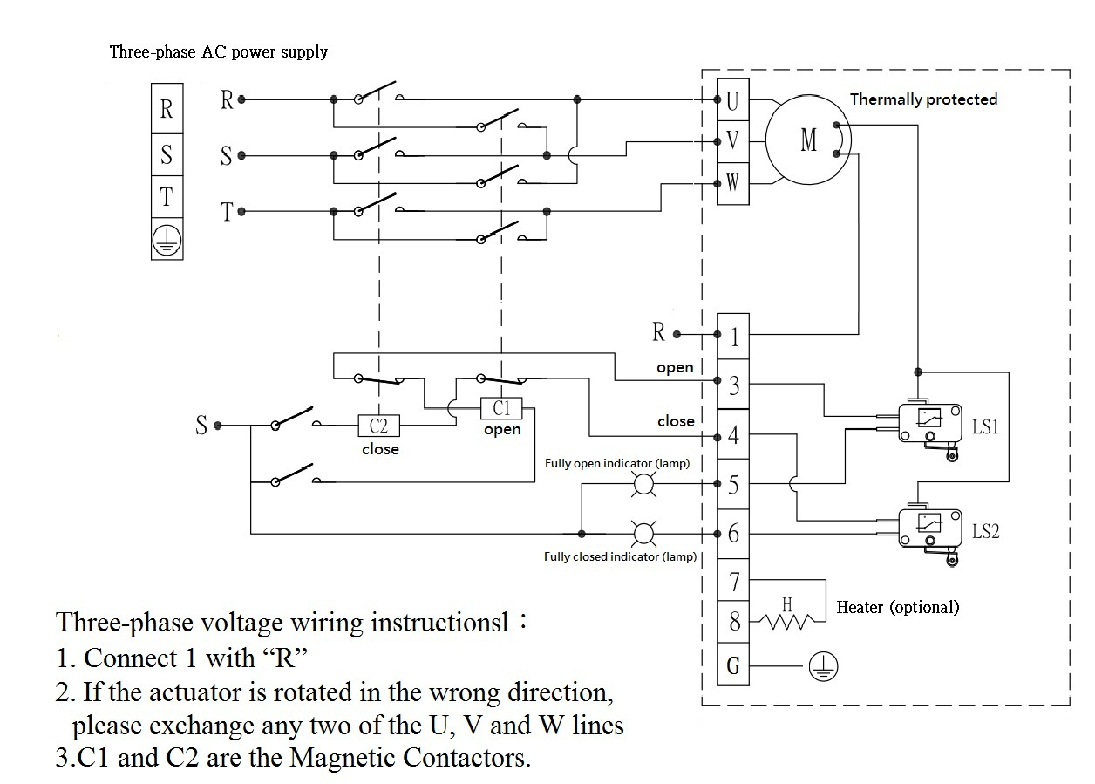

Auxiliary switch (optional)

Power Fang Enterprise Company Ltd
e-mail : pfpf01@gmail.com
What’s App : 886 955789002
Tel no.: 886 2 8283 9836

“Modulation” Type, AMD Board 24/110/220V_{AC}
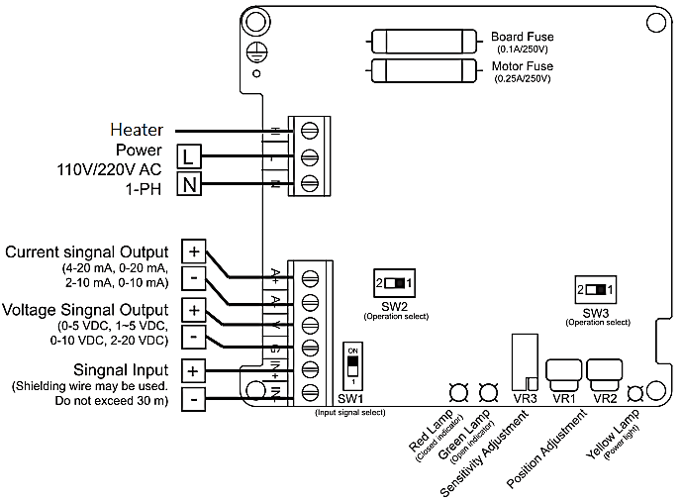
Motor Fuse
Board Fuse
(0.15A/250V)

(0-5 VDC, 0-5 VDC,
1-5 VDC, 1-5 VDC,
0-10 VDC, 0-10 VDC)
(4-20 mA, 4-20 mA,
2-10 mA, 2-10 mA)

Auxiliary switch
(optional)
(Optional)

“Modulation” Type, BMD Board 110/220V_{AC}
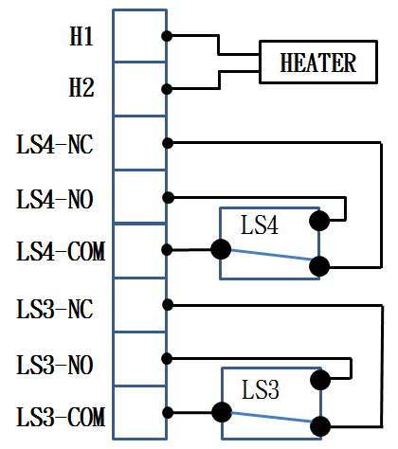
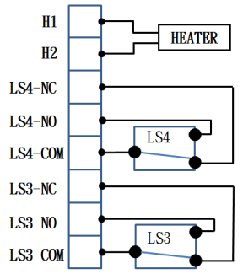
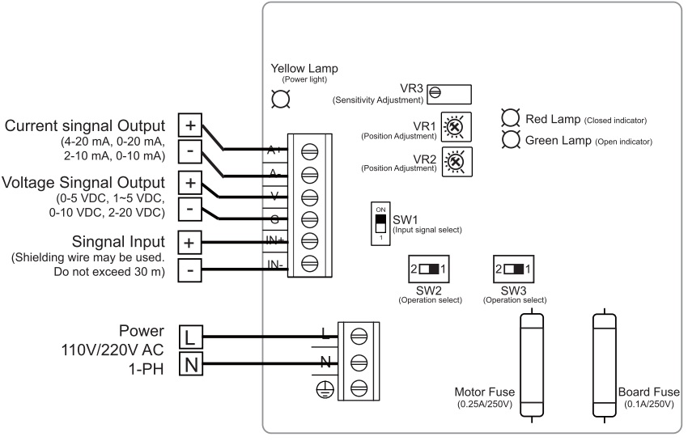
Board Fuse
(0.15A/250V)

(0-5 VDC, 0-5 VDC,
1-5 VDC, 1-5 VDC,
0-10 VDC, 0-10 VDC)

(4-20 mA, 4-20 mA,
2-10 mA, 2-10 mA)

Auxiliary switch
(optional)
Power Fang Enterprise Company Ltd
e-mail : pfpf01@gmail.com
What’s App : 886 955789002
Tel no.: 886 2 8283 9836

Signal Flow of Modulation Type
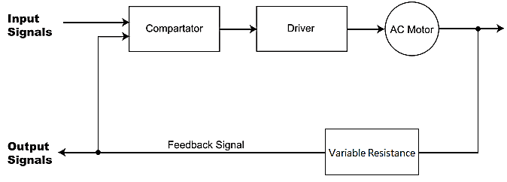

Switch & Adjustment Settings
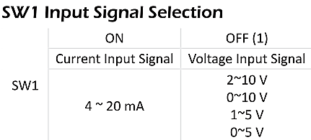 | 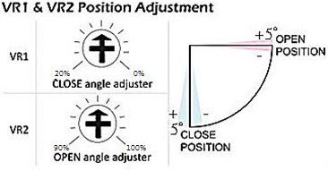

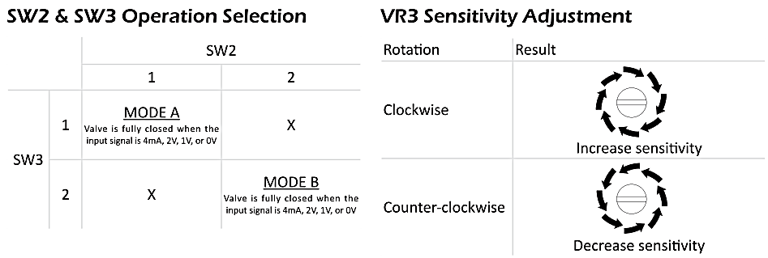
Power Fang Enterprise Company Ltd
e-mail : pfpf01@gmail.com
What’s App : 886 955789002
Tel no.: 886 2 8283 9836
“Battery Backup Fail-safe” Type, 110/220V_{AC}, 12V_{DC} and 24V_{AC/DC}
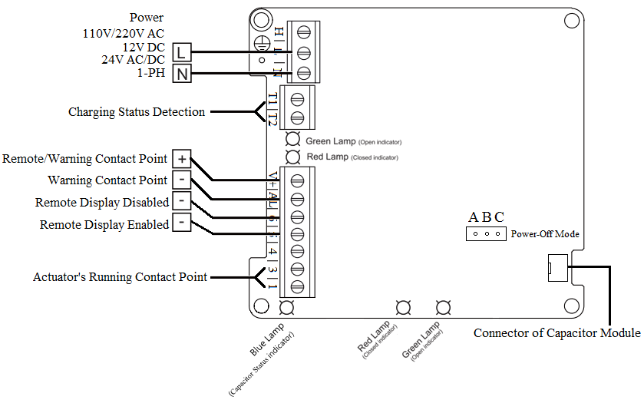
Power-Off Mode Setting
Setting method | Action mode
Connect A with B | The actuator will be switched ON in power-off status.
Connect B with C | The actuator will be switched OFF in power-off status.

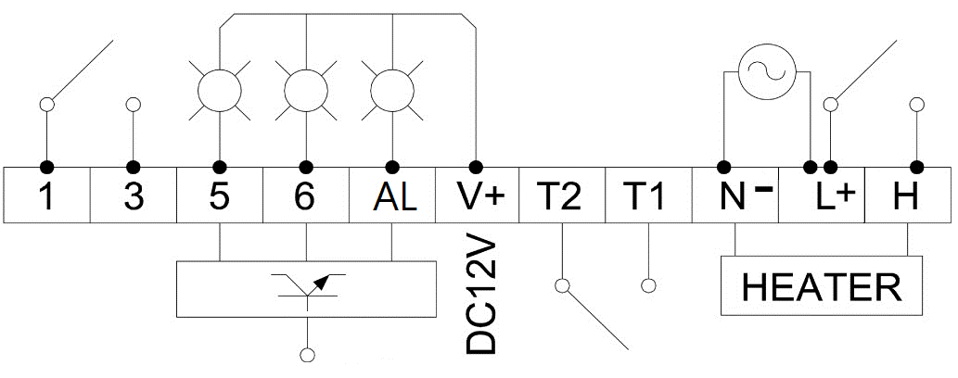
Auxiliary switch (optional)

*The functional contact point(4-NC, 4-NO, 4-COM) and the functional contact point(3-NC, 3-NO, 3-COM) are the auxiliary switch with the capacity of AC220V/0.1A.
Power Fang Enterprise Company Ltd
e-mail : pfpf01@gmail.com
What’s App : 886 955789002
Tel no.: 886 2 8283 9836
DIMENSIONS
JS-01~02 |  | Flange type: F03, F04, F05, F07
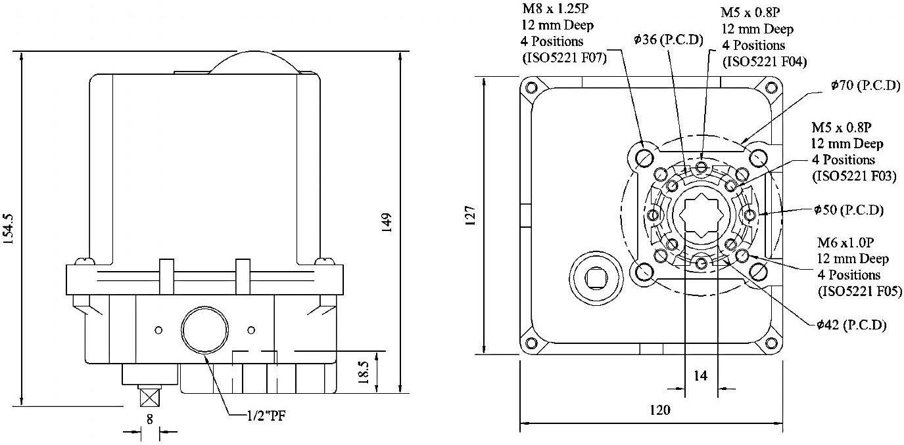
Unit: mm
JS-03 | Flange type: F05, F07
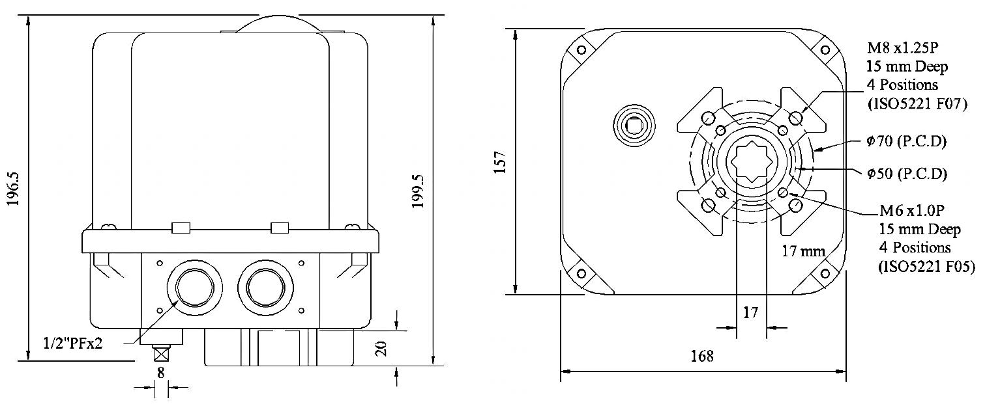
Unit: mm
JS-03H~06H | Flange type: F07, F10, F12
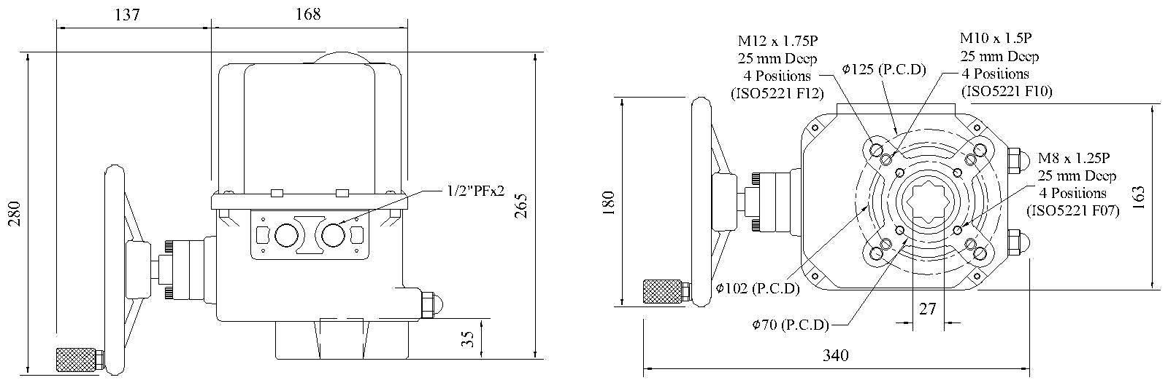
Unit: mm
JS-06H-T08~T10 | Flange type:F10, F12&F10, F14
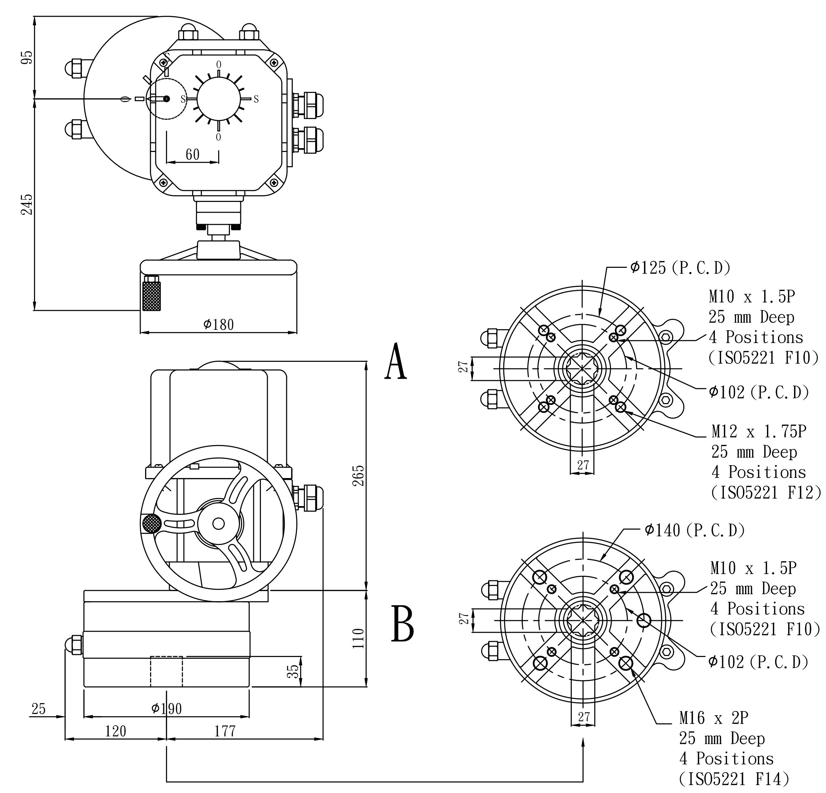
Unit: mm

Power Fang Enterprise Company Ltd
e-mail : pfpf01@gmail.com
What’s App : 886 955789002
Tel no.: 886 2 8283 9836

Power Fang Enterprise Company Ltd
JS - Series Actuator To Valve Selection Chart
Model No. | Valve Type | Valve Size(inch) | Valve Material
JS-01 | Screwed Ends Ball Valve | 1/2”~1-1/2” | SUS316/PVC/PP
JS-02 | Screwed Ends Ball Valve | 1/2”~2” | SUS316/PVC/PP
JS-03 | Screwed Ends Ball Valve | 1-1/4”~ 3” | SUS316/PVC/PP
JS-03H | Screwed Ends Ball Valve | 1-1/2”~3” | SUS316/PVC/PP
JS-01 | Socket Welded Ends Ball Valve | 1/2”~1-1/2” | PVC/PP
JS-02 | Socket Welded Ends Ball Valve | 1/2”~2” | PVC/PP
JS-03 | Socket Welded Ends Ball Valve | 2”~ 3” | PVC/PP
JS-03H | Socket Welded Ends Ball Valve | 2”~ 3” | PVC/PP
JS-04H | Socket Welded Ends Ball Valve | 4” | PVC/PP
JS-01 | Flanged Ends Ball Valve | 1/2”~1” | Cast Iron/SUS304/SUS316
JS-02 | Flanged Ends Ball Valve | 1-1/4”~2” | Cast Iron/SUS304/SUS316
JS-03 | Flanged Ends Ball Valve | 1-1/4”~3” | Cast Iron/SUS304/SUS316
JS-03H | Flanged Ends Ball Valve | 1-1/4”~3” | Cast Iron/SUS304/SUS316
JS-04H | Flanged Ends Ball Valve | 4” | Cast Iron/SUS304/SUS316
JS-05H | Flanged Ends Ball Valve | 5” | Cast Iron/SUS304/SUS316
JS-06H | Flanged Ends Ball Valve | 6” | Cast Iron/SUS304/SUS316
JS-01 | 3-Way Screwed Ends Ball Valve | 1/2”~1” | SUS316
JS-02 | 3-Way Screwed Ends Ball Valve | 1-1/4”~1-1/2” | SUS316
JS-03 | 3-Way Screwed Ends Ball Valve | 1-1/4”~2” | SUS316
JS-02 | 3-Way Flanged Ends Ball Valve | 1” | Cast Iron/SUS304/SUS316
JS-03 | 3-Way Flanged Ends Ball Valve | 1-1/2”~2” | Cast Iron/SUS304/SUS316
JS-03H | 3-Way Flanged Ends Ball Valve | 1-1/2”~2-1/2” | Cast Iron/SUS304/SUS316
JS-04H | 3-Way Flanged Ends Ball Valve | 3” | Cast Iron/SUS304/SUS316
JS-05H | 3-Way Flanged Ends Ball Valve | 4” | Cast Iron/SUS304/SUS316
JS-06H | 3-Way Flanged Ends Ball Valve | 5” | Cast Iron/SUS304/SUS316
JS-02 | Butterfly Valve | 2”~3” | Cast Iron/SUS304/SUS316
JS-03 | Butterfly Valve | 2”~5” | Cast Iron/SUS304/SUS316
JS-03H | Butterfly Valve | 2”~6” | Cast Iron/SUS304/SUS316
JS-04H | Butterfly Valve | 8” | Cast Iron/SUS304/SUS316
JS-05H | Butterfly Valve | 10” | Cast Iron/SUS304/SUS316
JS-06H | Butterfly Valve | 10” | Cast Iron/SUS304/SUS316
Notes:
- Please check valve torque before mounting.
- Please check working pressure, service fluid, and temperature.
Power Fang Enterprise Company Ltd
e-mail : pfpf01@gmail.com
What’s App : 886 955789002
Tel no.: 886 2 8283 9836

